**1st Term Poems – Due: ___________________**

C:\Users\Dave\AppData\Local\Microsoft\Windows\INetCache\IE\TO2OZVPU\MC900437457[1].wmf**Afternoon on a Hill**

*By Edna St. Vincent Millay*

I will be the gladdest thing

Under the sun!

I will touch a hundred flowers

And not pick one.

I will look at cliffs and clouds

With quiet eyes,

Watch the wind blow down the grass,

And the grass rise.

And when lights begin to show

Up from the town,

I will mark which must be mine,

And then start down!

**Summer Shower**

*By David McCord*

Window window window pane:

Let it let it let it rain

Drop by drop by drop by drop.

Run your rivers from the top

Zigzaggy down, like slow wet forks

Of lightning, so the slippery corks

Of bubbles float and overtake

Each other till three bubbles make

A kind of boat too fat to fit

The river. That's the end of it.

 Straight

down

it

slides

and

with

a

splash

Is lost against the window sash.

Window window window pane:

Let it let it let it rain.

**Growing Up**

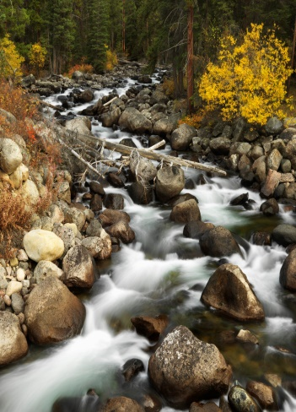*By Harry Behn*

When I was seven

We went for a picnic

Up to a magic

Foresty place.

I knew there were tigers

Behind every boulder,

Though I didn't meet one

Face to face.

When I was older

We went for a picnic

Up to the very same

Place as before,

And all of the trees

And rocks were so little

They couldn't hide tigers

Or me anymore.

**Early**

*By Harry Behn*

Before the sun was quite awake

I saw the darkness like a lake

Float away in a little stream

As swift and misty as a dream.

It left the morning oh so still

Except when once a whippoorwill

Up in the orchard whispered a word

And once a frog trilled like a bird.

Then I could only think of me,

And what a nicer child I'd be

If I could learn to walk as still

As morning sunlight on a hill.