3rd Term Poems – Due: __________________

The Frost Pane
By David McCord

What's the good of breathing
On the window
Pane
In summer?
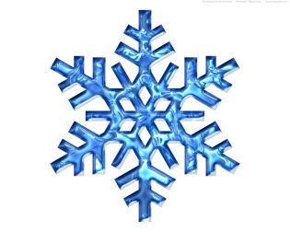
You can't make a frost
On the window pane
In summer.
You can't write a
Nalphabet
You can't draw a
Nelephant.
You can't make a smudge
With your nose
In summer.
Lots of good, breathing
On the window
Pane
In winter.
You can make a frost
On the window pane
In winter.
A white frost, a light frost,
A thick frost, a quick frost,
A write-me-out-a-picture-frost
Across
The pane
In
Winter.
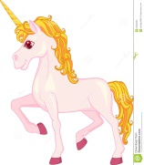
Unicorn
By William Jay Smith

The Unicorn with the long white horn
Is beautiful and wild.
He gallops across the forest green
So quickly that he’s seldom seen
Where Peacocks their blue feathers preen
And strawberries grow wild.

He flees the hunter and the hounds,
Upon black earth his white hoof pounds,
Over cold mountain streams he bounds
And comes to a meadow mild;
There, when he kneels to take his nap,
He lays his head in a lady’s lap
As gently as a child.

Humanity
By Elma Stuckey

If I am blind and need someone
To keep me safe from harm,
It matters not the race to me
Of the one who takes my arm.

If I am saved from drowning
As I grasp and grope,
I will not stop to see the face
Of the one who throws the rope.

Or if out on some battlefield
I'm falling faint and weak,
The one who gently lifts me up
May any language speak.

We sip the water clear and cool,
No matter the hand that gives it.
A life that's lived worthwhile and fine,
What matters the one who lives it?

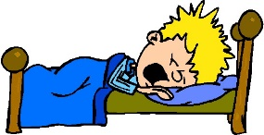
Sleepy Harry
By Kate Greenaway

“I do not like to go to bed,”
Sleepy little Harry said;
“Go, naughty Betty, go away,
I will not come at all, I say!”

Oh, silly child! What is he saying!
As if he could be always playing!
Then, Betty, you must come and carry
This very foolish little Harry.

The little birds are better taught,
They go to roosting when they ought;
And all the ducks, and fowls, you know,
They went to bed an hour ago.

The little beggar in the street,
Who wanders with his naked feet,
And has not where to lay his head,
Oh, he’d be glad to go to bed.

