Every Time I Climb a Tree
By David McCord
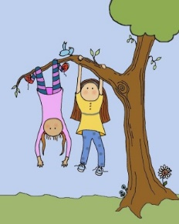
Every time I climb a tree
Every time I climb a tree
Every time I climb a tree
I scrape a leg
Or skin a knee
And every time I climb a tree
I find some ants
Or dodge a bee
And get the ants
All over me.

And every time I climb a tree
Where have you been?
They say to me
But don't they know that I am free
Every time I climb a tree?

I like it best
To spot a nest
That has an egg
Or maybe three.

And then I skin
The other leg
But every time I climb a tree
I see a lot of things to see
Swallows, rooftops and TV
And all the fields and farms there be
Every time I climb a tree
Though climbing may be good for ants
It isn't awfully good for pants
But still it's pretty good for me
Every time I climb a tree.

Raindrops
By Harry Behn
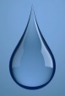
They tap like fingers on the window pane,
But they aren't fingers, they are only rain.

They fall the way bees do into a flower,
But they aren't bees; they're pieces of a shower.

They jump in puddles just like little men,
Then they aren't ever even rain again,

They're simply water wrinkled by the motion
Of streams and rivers till they're only ocean.

But ocean turns to waves, and waves to sprays
And mist, and sometimes on a sunny day

Mist sails up to the sky above the shrouds
Of ships and there wind blows it into clouds.

Then raindrops fall again. Unless they're snow.
My teacher told me this, and so it's so.
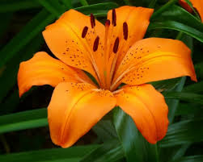
What is Orange?
By Mary O’Neill
The brightest stripe
In a Roman sash.
Orange is an orange
Also a mango
Orange is music
Of the Tango.
Orange is the fur
Of the fiery fox,
The brightest crayon
In the box.
And in the fall
When leaves are turning
Orange is the smell
Of a bonfire burning…

Orange is a tiger lily,
A carrot,
A feather from
A parrot,
A flame,
The wildest color
You can name.
Orange is a happy day
Saying good-by
In a sunset that
Shocks the sky.
Orange is brave
Orange is bold
It’s bittersweet
And marigold.
Orange is zip
Orange is dash

Coloring
By Harry Behn

A rake, a coat, a meadow, a mill,
A cake, a boat, a house on a hill,
A kite, a spade, and a ball of string,
A wind in the leaves, and the song birds sing-
It's Spring!
We're outdoors coloring
Every bright beautiful wonderful thing.

Under a lilac bush we've made
A studio with walls of shade,
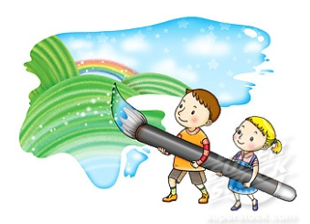
And in our painting books we spread
Pools of yellow, blue, and red-
Carefully,
Though it doesn't matter
Terribly much unless we spatter.

Green and red, and there's a tree
With apples and cherries, and here's a sea
With a wave and a sky and a gull in flight,
And this is the sun splashing light-
It's Spring!
We're coloring, and all the birds sing
Of every bright beautiful wonderful thing!

